Instructions for downloading and upgrading the latest version of Cisco Anyconnect.

Prerequisites
To download Cisco Anyconnect, you must first have administrator rights to your computer. If you do not have administrator rights to your computer, you will have to work with your IT group. If you have an outdated version of Cisco, it is recommended that you uninstall the old version before installing the new version.
- After navigating to downloads.tbi.tn.gov/tbivpn, click on the .msi file that starts with cisco. At the time of the document, the current version is cisco-secure-client-win-5.1.1.42-core-vpn-predeploy-k9.msi

- After the file has downloaded, locate the file and open.

- Click next on the opening prompt.
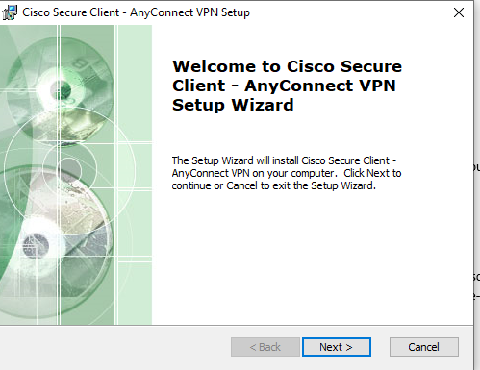

- Click I accept the terms in the License Agreement and click next.
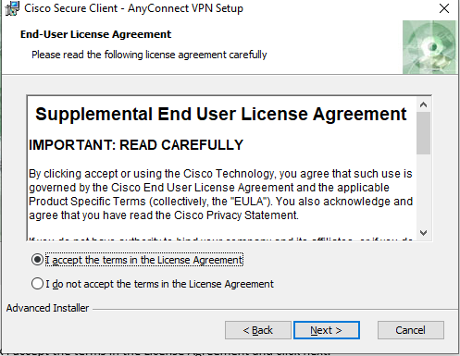

- Click Install
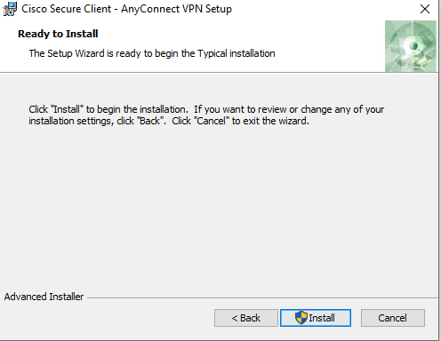

- The following screen appears.
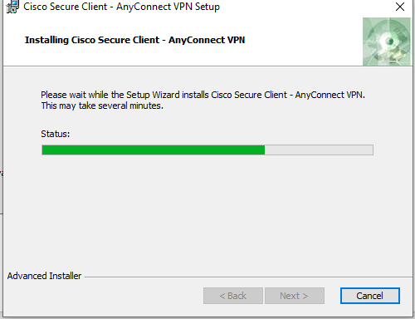

- Click finish.


- Locate the application. This can easily be done by going to start and searching Cisco. You may also want to pin the application to the Task Bar for convenience.



- Open the program and type tbivpn.tbi.tn.gov in the box.
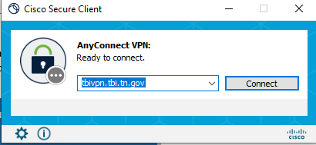

- Select LEA-TwoFactor from the group.
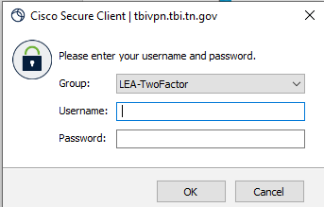

- After entering your credentials and you will then be prompted to input your pin.

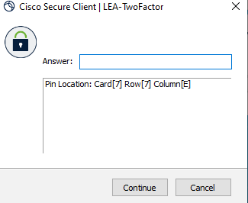

- After entering your pin, you should now be connected.

