Instructions for logging into Cisco AnyConnect before logging into computer

These instructions assume the user doesn’t have the latest version of Cisco AnyConnect with the Start Before Logon feature installed. If these have been installed, skip to step 10

- Navigate to https://downloads.tbi.tn.gov/tbivpn/ and click on cisco-secure-client-win-5.0.02075-core-vpn-predeploy-k9.msi and cisco-secure-client-win-5.0.02075-sbl-predeploy-k9.msi to download.

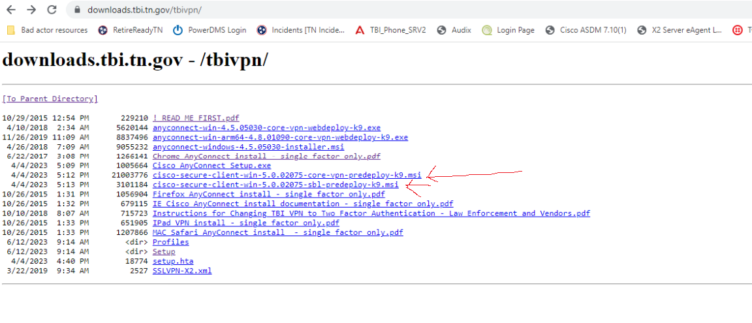
- Locate the files (default is usually in the downloads folder) and double click 5.0.02075-core-vpn-predeploy-k9.msi to install. The following box appears.


- Click Next and the following dialog box will appear.
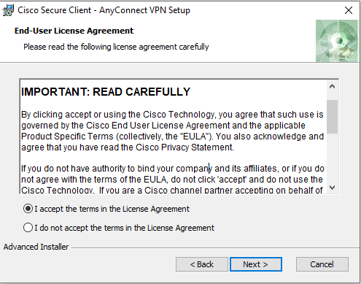
- Select “I accept the terms in the License Agreement” and click next. The following dialog box appears.
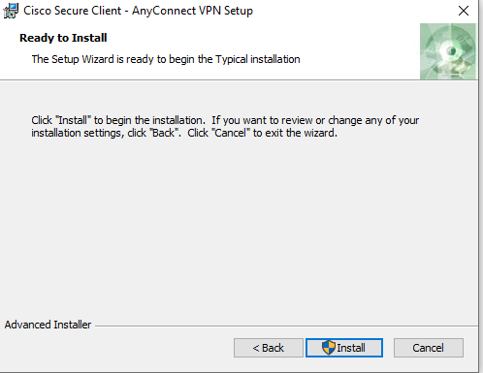
- Click Install and following dialog box appears.

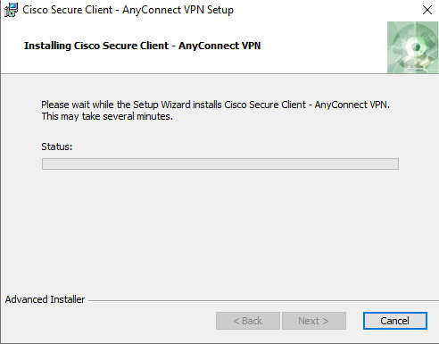

- After installation is complete, click finish.
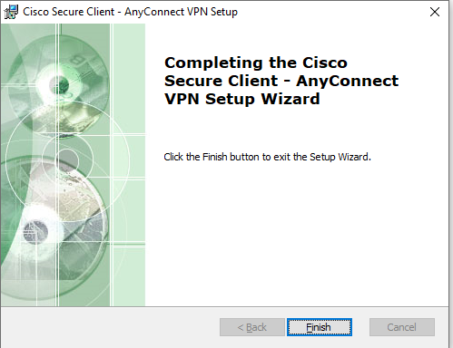
- Locate the downloaded file cisco-secure-client-win-5.0.02075-sbl-predeploy-k9.msi and double-click to install.

- Just as with the previous installation, click next and install on the following dialog boxes.

- Restart your computer when prompted.

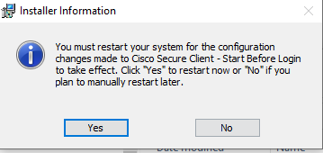

Optional: After restart, click Start and under Recently Added, right click Cisco AnyConnect, hover the mouse over more and click Pin to Taskbar.
- Open Cisco AnyConnect and type tbivpn.tbi.tn.gov if you haven’t connected before otherwise make sure TBI-TwoFactor is selected and click connect.

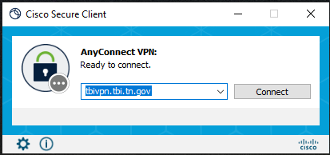

- After you have connected to the VPN, open AnyConnect again and click on the gear icon on the bottom left.

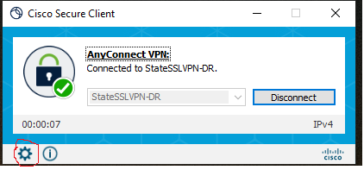
- Under the Preferences tab, select Star VPN before user logon to computer.
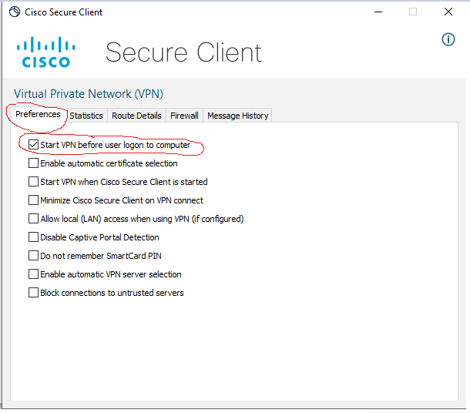
- Close the Cisco Secure Client Box and restart your computer

- At the login screen, click the icon to the left of the network connections icon.



- When the Cisco Secure Client appears, connect as you normally would, and the process is finished.


